|  |
| --- |
| CIT |
| Copyright and Internet Reflection |
| SOFTWARE DEVELOPMENT 3 |

|  |
| --- |
| Kitman Yiu  2015/6/10 |

Content

Introduction 3

What and why does it have latency? 3

Why does it have processing load? 3

NETWORKING architecture 4

OSI 4

What does it affect? Why does it affect? 4

HOw DOES OSI effect players? 4

How to fix it? 4

Protocol 4

What does it effect? Why does it effect? 4

If it effect, how does it affect people? 4

How can we fix it? 4

Header Information 5

Bandwidth 7

What does it effect? Why does it effect? 7

If it is, how does it affect gamers and other users? 7

How can we fix it? 7

ASIC/FGPA 7

What does it effect? Why does it effect? 7

If it effect, how does it effect people? 7

How can we fix it? 7

Communication Architecture 8

What does it affect? Why does it affect? 8

How does it affect? 8

How to fix it? 8

Latency hiding techniques 9

What does it effect? Why does it effect? 9

How does it effect? 9

How can we fix 9

Cryptography Methods 9

What does it affect? Why does it affect? 9

How does it affect the player? 9

How can we fix 9

Security 10

What does it affect? Why does it affect? 10

How does it effect to player? 10

How can we fix 10

Conclusion 11

REFERENCE 12

# Introduction

## Ditgitak Millenium Copyright Act (DMCA)

Since my project would be consider to be publish online, one ??? should watch out

An overview of DMCA

This is under U.S copyright law : prohibits use & distribution of technology which circumvents measures that control access to copyright works , These include things that will break the Digital Rights management (DRM) , for example decrpt DVDs - e-Book , DRM removal tools and some types of reverse engineering , may also prevent analysis of protocols by inspecting networking traffic. And also we have a fair trade agreement with U.S. Which means we have our own DMCA

Make sure what to don and not

## Open Source Licences

These are proprietary(“commercial ”) copyright licences prevent the customer from doing certain things with their things with their copy of a creative work such as :copy , redistribute ,decompile , modify etc.

Before using it , it will be your resonbiltie to read the licence agreeements to make sure that I don’t do anything wrong

The open source copyright licences tend to give specific rights (“freedoms”) to the customers as well as preventing certain things

The following list are some examples of open source licences

## General Public Licence (GPL)

This is Licence is under open source licence and also the most popular one , the licence give us freedom such as

Run the program

Study and change the program , for any purpose

FRedistribute copies of the program to anybody

Redistribute modified copies of the program to anybody

### What does it affect? Why does it affect?

OSI decreases the processing load by giving a universal standard which the computer can use to send data in a more efficient manner. Without OSI, time is required to convert data from one standard to another.

### HOw DOES OSI effect players?

Since the processing load had been decrease the time of processing data.

### How to fix it?

In order to resolve the problem of high processing loads caused by incompatible standards, the OSI was introduced as model standard. Similar to a blueprint of a car, the OSI is a scaled-down representation of the actual data transmitting process.

## Protocol

### What does it effect? Why does it effect?

Protocol affects the processing load because without it, the processing load will be increased during the conversion from one set of rules to another. It may also be unable to process the data until it has been reconfigured or programmed manually.

### If it effect, how does it affect people?

More time would be required to convert them or a person may be required to manually convert them.

### How can we fix it?

Protocols can be set up to resolve this problem. In computer terms, a protocol can be defined as a common set of rules and signals that are used to communicate throughout a network. This will allow instructions to flow throughout the network and enable the processing of data. The two common sets of protocols are TCP and UDP.

TCP and UDP have the responsibility to provide important information such as the origin and expected destination of the data. As seen below in the table, there are differences between TCP and UDP.

|  |  |  |
| --- | --- | --- |
|  | **TCP** | **UDP** |
| **Header Information** | More | Less |
| **Three Hand Shake** | Yes | No |
| **Coding** | Less | More |

#### Header Information

The following diagram demonstrates what is inside TCP and UDP headers.

TCP Header

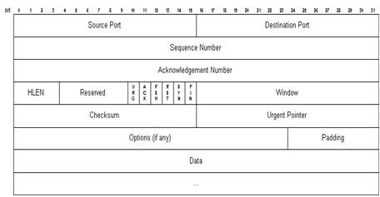

UDP Header

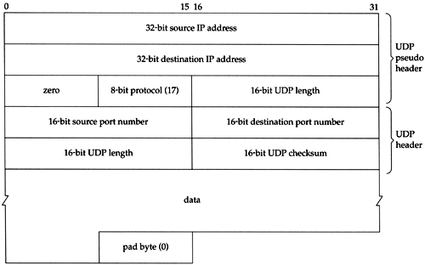

As we can clearly see from the above image the TCP contains more information than UDP, which means TCP needs more time to build up then UDP. In other words, it means TCP has more latency then UDP. The extra information in the TCP headers are to check that all the information has been received and the order of the information.

#### Three WAY Hand Shake

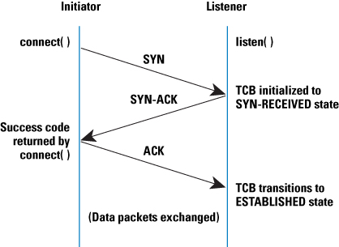

The three hand shake which only exists in TCP has the responsibility to create a connections between a host or client and the server to make sure that the client has existed prior to transferring data.

#### Coding

A reason why TCP requires less time to code is that the data knows how to automatically compress and segregate the data into smaller parts. On the other hand, UDP requires manual coding to ensure that the data will not be lost at any time during the process. This automated process of compressing and separating requires time.

#### What should we choose?

* UDP + TCP
* TCP or UDP

The able to answer this question we would need to know

* What type of game you are making
* How much time you have.

|  |  |  |  |
| --- | --- | --- | --- |
|  | TCP | UDP | Reason |
| Player point of view |  |  | Faster |
| Small games point of view |  |  | Will be using more time by the developer |
| Large games point of view |  |  | Because UDP can sends and receives data faster than TCP. |

## Bandwidth

### What does it effect? Why does it effect?

The bandwidth will affect the latency by changing the amount of data which can be sent through the Internet whereas no bandwidth it means data cannot be send through.

### If it is, how does it affect gamers and other users?

The player would need to use more time to wait until they can receive that data. If there is no bandwidth, it means no data can be sent through.

### How can we fix it?

In order to fix this problem, a higher bandwidth would be required. Bandwidth controls the amount of data that can be transmitted in a fixed amount of time. Since bandwidth is related to the physical layer of the OSI model, an increase in bandwidth can be achieved through changing the equipment like cables or routers.

## ASIC/FGPA

### What does it effect? Why does it effect?

This can affect the processing load and latency. Without ASIC and FPGA people would need to write function on the CPU. In other word that means it increase the processing load of CPU.

### If it effect, how does it effect people?

The player would need to use more time to wait until they can receive that data. If there is no bandwidth, it means no data can be sent through.

### How can we fix it?

**(Gpu vs fpga. 2015.)**To able to solve the problem some people created a clip with a program which are called ASIC and FGPA. It is similar when you are upgrading all the clip in your car factory. ASIC and FPGA decreases both processing load and latency by creating a clip and it’s [integrated circuit](http://en.wikipedia.org/wiki/Integrated_circuit) is designed to be configured by a customer or a designer after manufacturing which enables them to decrease the processing load and latency.

## Communication Architecture

**(Understanding the differences between client/server and peer-to-peer networks - TechRepublic. 2015.)**

Communication architecture is include two elements

* Hardware (such as Router , cables )
* Type of networks(such as Bus , Ring ,Tree)

### What does it affect? Why does it affect?

This can affect the processing load and latency because it will change the physical device such as Router/ cable/ Wi-Fi card …etc., and also changes how the computers are connected together. The difference between ASIC and FPGA is similar you replacing a single clip inside every machines in the car factory which communication architecture replaces the machines and their position that the machine are located.

### How does it affect?

Without having the computer physically connecting, it is the same as the OSI missing the 7 layers.

### How to fix it?

There are two ways to fix this problem through the client/server or the P2P networking as shown by the image below.

Two types of Networking are known as Client/Server and P2P networking, an image is showed below:

# Latency hiding techniques

## What does it effect? Why does it effect?

Latency hiding techniques do not improve the latency but substitutes the latency. You can imagine when you making scale down model of your car you won’t actually use glass for the car window, what you will do is to put a plastic paper to similar there are car windows.

## How does it effect?

These techniques use some tricks on the client’s side to improve the player’s experience.

## How can we fix

Two of the common methods cheating latency are **(Fundamentals of Network Game Development - Brian)**

* Dead – Reckoning
* Lockstep Protocol

# Cryptography Methods

Cryptography is like having a blueprint which can only be interpreted by you. It is designed to protect the player information so even if hacked, the information will not be easily interpreted.

## What does it affect? Why does it affect?

Cryptography can increases both latency and processing load because more information would need to be send over the internet.

## How does it affect the player?

It would need to take more time for the player to actually receive the information that he needs.

## How can we fix

Since it is necessary to have it, there are only two options:

1. Choose a method that already balances both security and speed
2. Creating a new algorithm

But since both methods would need to take a huge amount of time to research and understand they will not be discussed. However I will still list the common Cryptography Algorithm**. (Cryptographic Algorithms. 2015)**

* [Public Key Algorithms](http://www.cryptopp.com/algorithms.html#asymmetric)
* [Secret Key Algorithms](http://www.cryptopp.com/algorithms.html#symmetric)
* [Block Cipher Modes](http://www.cryptopp.com/algorithms.html#modes)
* [Cryptographic Hash Functions](http://www.cryptopp.com/algorithms.html#hash)
* [Random Number Generators](http://www.cryptopp.com/algorithms.html#random)

Another interesting way to do it is to move the Cryptography algorithms to FPGA and GPU

(Graphics processing unit) which a chip? in the graphic cards , moving it to FPGA allows us to decrease the CPU processing load , which means the CPU just needs to send and receive the data from FPGA .This is the same as GPU which has multi-threading so the CPU would just need to send data and receive data from the GPU.

# Security

## What does it affect? Why does it affect?

Security Algorithm increases both latency and processing load because more information would need to be send over the internet and also more steps would be required before and after receiving the data.

## How does it effect to player?

It is would need to take more time that the player actually receive the things that he need.

## How can we fix

First of all we need to found out how much latency the security takes

To able to know how much latency it takes us my website [www.kitmanyiu.com](http://www.kitmanyiu.com) has programed the list below of common possible attacks **(How to Create a Secure Login Script in PHP and MySQL):**

* [SQL Injections](https://www.owasp.org/index.php/SQL_Injection)
* [Session Hijacking](https://www.owasp.org/index.php/Session_hijacking_attack)
* [Network Eavesdropping](https://www.owasp.org/index.php/Network_Eavesdropping)
* [Cross Site Scripting](https://www.owasp.org/index.php/Cross-site_Scripting_%28XSS%29)
* [Brute Force Attacks](https://www.owasp.org/index.php/Blocking_Brute_Force_Attacks)

By opening Google Chrome is and pressing F12 there is a window that can show us how much latency it takes us to login.

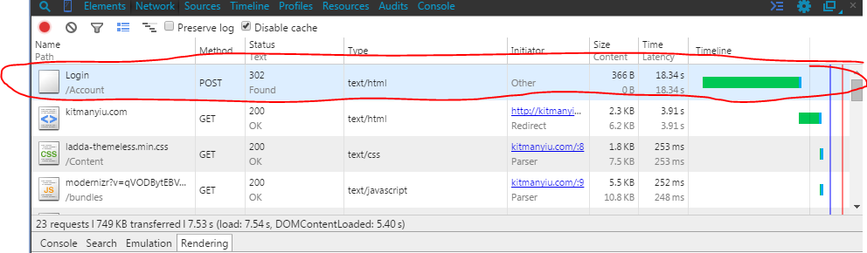

As the result we can see that the security check takes us 18.34ms of Time Latency, and this is only checking the common possible attacks that has, but in an online game there will be much more security checks for example: avoid the player’s from losing any money or weapons or stealing equipment’s from the store.

So there will be two solutions to decrease the latency and process load. The first one is Create a new security methods to decrease the CPU processing load by that the latency will be shorter, another solution is to also put the algorithms to GPU and FPGA but since there is no information by now, but it will be possible in some day.

# Conclusion

The reasons for high latency can be related to two main things. First, the processing load of CPU and second the hardware that transfers data. To be able to solve the problem we can either choose to create a new algorithm or decrease the CPU processing load by calculating the data on CPU and FPGA, or we can choose to upgrade our hardware.

# REFERENCE

High throughput implementations of cryptography algorithms on GPU an…. 2015. High throughput implementations of cryptography algorithms on GPU an…. [ONLINE] Available at: <http://www.slideshare.net/nitin3940/high-throughput-implementations-of-crypto>. [Accessed 08 May 2015].

Xilinx® : What is an FPGA? Field Programmable Gate Array. 2015. Xilinx® : What is an FPGA? Field Programmable Gate Array. [ONLINE] Available at:<http://www.xilinx.com/training/fpga/fpga-field-programmable-gate-array.htm>. [Accessed 08 May 2015].

The comparison between FPGA, ARDUINO, ASIC. 2015. The comparison between FPGA, ARDUINO, ASIC. [ONLINE] Available at:<http://www.slideshare.net/mohamedyoussery/the-comparison-between-fpga-arduino-asic?qid=7bcaffbd-f160-4daa-a489-b73cdf7aa0f4&v=default&b=&from_search=2>. [Accessed 08 May 2015].

Gpu vs fpga. 2015. Gpu vs fpga. [ONLINE] Available at:<http://www.slideshare.net/yukitakatakemura/gpu-vs-fpga-28140187?qid=7bcaffbd-f160-4daa-a489-b73cdf7aa0f4&v=default&b=&from_search=15>. [Accessed 08 May 2015].

GDC 2015 - Low-latency Multiplayer Gaming with AWS . 2015. GDC 2015 - Low-latency Multiplayer Gaming with AWS . [ONLINE] Available at:<http://www.slideshare.net/nateware/gdc-2015-lowlatency-multiplayer-gaming-with-aws?qid=af692ab9-5e2c-475d-860e-5a2960202355&v=default&b=&from_search=1>. [Accessed 08 May 2015].

Network Matchmaking From Networking Expert - Matchmaking - Warframe Forums. 2015. Network Matchmaking From Networking Expert - Matchmaking - Warframe Forums. [ONLINE] Available at:<https://forums.warframe.com/index.php?/topic/376373-network-matchmaking-from-networking-expert/>. [Accessed 08 May 2015].

Gaffer on Games | Glenn Fiedler's Game Development Articles. 2015.Gaffer on Games | Glenn Fiedler's Game Development Articles. [ONLINE] Available at: <http://gafferongames.com/>. [Accessed 08 May 2015].

How to Create a Secure Login Script in PHP and MySQL - wikiHow. 2015.How to Create a Secure Login Script in PHP and MySQL - wikiHow. [ONLINE] Available at: <http://www.wikihow.com/Create-a-Secure-Login-Script-in-PHP-and-MySQL>. [Accessed 08 May 2015].

 Cryptographic Algorithms . 2015. Cryptographic Algorithms . [ONLINE] Available at: <http://www.cryptopp.com/algorithms.html>. [Accessed 08 May 2015]..

Fundamentals of Network Game Development - Brian Schwab - Google Books. 2015. Fundamentals of Network Game Development - Brian Schwab - Google Books. [ONLINE] Available at: <https://books.google.com.au/books?id=aa8LAAAAQBAJ&pg=PA220&lpg=PA220&dq=%22Dead+%E2%80%93+Reckoning%22+AND+%22Lockstep+Protocol%22&source=bl&ots=w9h2NViclD&sig=n50rCZcKlHS-Y7dcjzXmv3GiKbY&hl=en&sa=X&ei=96tMVauzCsLAmwXQ04DgAQ&ved=0CCUQ6AEwAQ#v=onepage&q=%22Dead%20%E2%80%93%20Reckoning%22%20AND%20%22Lockstep%20Protocol%22&f=false>. [Accessed 08 May 2015].

How TCP/IP Works - YouTube. 2015. How TCP/IP Works - YouTube. [ONLINE] Available at: <https://www.youtube.com/watch?v=HOaIqQAeaik>. [Accessed 08 May 2015].

Understanding the differences between client/server and peer-to-peer networks - TechRepublic. 2015. Understanding the differences between client/server and peer-to-peer networks - TechRepublic. [ONLINE] Available at: <http://www.techrepublic.com/article/understanding-the-differences-between-client-server-and-peer-to-peer-networks/>. [Accessed 08 May 2015].